**LAB#07**

**OBJECT: Consider the following equation and draw the circuit using NOR gate only.**

**X = $\overline{A}$ +BC**

**APPARATUS:**

* 74LS08
* 74LS04
* 74LS32
* Bread Board
* Connecting Wires
* LED
* DC Supply

**SYMBOLS:**



NOR GATE

**TRUTH TABLE:**

|  |  |  |  |
| --- | --- | --- | --- |
| **A** | **B** | **C** | **OUTPUT**  **X = $\overline{A}$ + BC** |
| 0 | 0 | 0 | 1 |
| 0 | 0 | 1 | 1 |
| 0 | 1 | 0 | 1 |
| 0 | 1 | 1 | 1 |
| 1 | 0 | 0 | 0 |
| 1 | 0 | 1 | 0 |
| 1 | 1 | 0 | 0 |
| 1 | 1 | 1 | 1 |

**CIRCUIT DESIGN:**

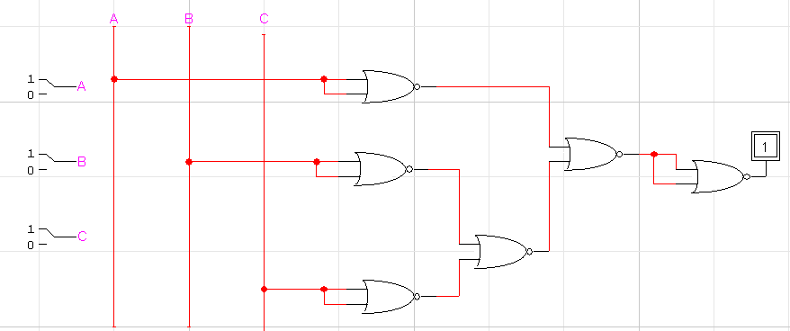

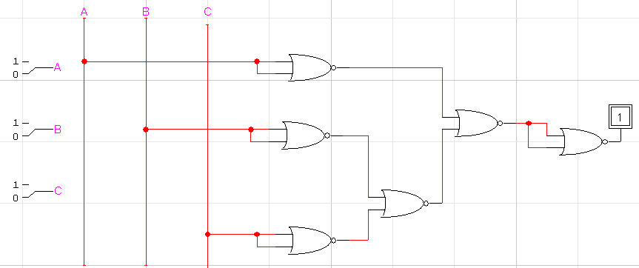

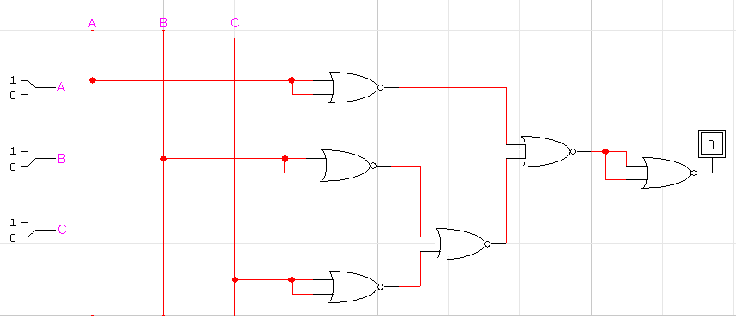

**CONCLUSION:**

The circuit is working according to the truth table.